**AVNET WCS-WCM INTEGRATION**

**By Infosys Limited**

**Version: 1.0**

**Release Date: AUGUST 2016**

**History of Changes**

|  |  |  |  |
| --- | --- | --- | --- |
| **Version** | **Date** | **Author** | **Notes** |
| 1.0 | 8 August 2016 | Infosys | Initial Release |

Contents

**Digital Portal Home Page** 4

**Top Navigation – Flyout Display** 5

**Search Functionality** 8

**Auto Suggest Functionality** 9

**Portal links in WCS header** 11

**WCS links in Portal Page header** 12

# **Digital Portal Home Page**

Home Page of Digital Portal would be WCM Page.

Below production URLs will be redirected to corresponding WCM Home Pages.

<https://products.avnet.com/emea>

Redirects to WCM Page

https://products.avnet.com/wps/portal/emea/!ut/p/z1/04_Sj9CPykssy0xPLMnMz0vMAfIjo8zi3S1NPQ2dnQ18DbzcLQwcAyy9QvwN_Q0sDEz0w8EKDHAARwP9KEL6o8BK8JhQkBthkO6oqAgA7NU3pw!!/dz/d5/L2dBISEvZ0FBIS9nQSEh/

<https://products.avnet.com/ema>

Redirects to WCM Page

https://products.avnet.com/wps/portal/ema/!ut/p/z1/04_Sj9CPykssy0xPLMnMz0vMAfIjo8zifRwtXT0cDYx83EN8nQwcLUODTJx9_AwMLAz0w_Wj9KOASgxwAEcD_YLsbEUA1epZrA!!/dz/d5/L2dBISEvZ0FBIS9nQSEh/

<https://products.avnet.com/asia>

Redirects to WCM Page

https://products.avnet.com/wps/portal/asia/!ut/p/z1/04_Sj9CPykssy0xPLMnMz0vMAfIjo8zi3S1NPQ2dnQ183c19nA0cAywdXUNCfAyAQD8crMAAB3A00I8ipD8KrASPCQW5EQbpjoqKANTWOOU!/dz/d5/L2dBISEvZ0FBIS9nQSEh/

EMEA Portal page

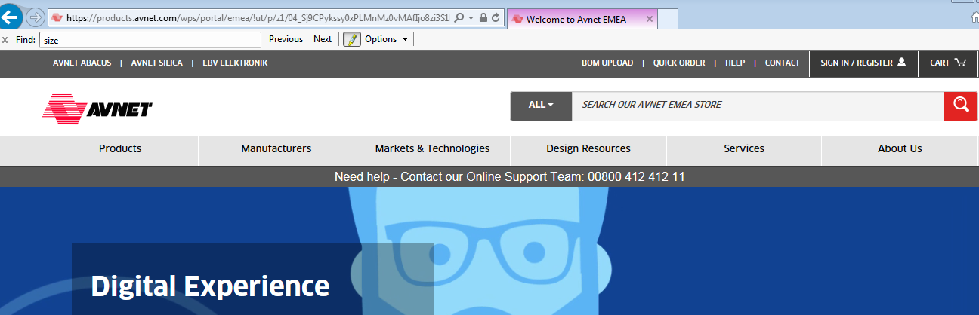

EMA Portal page

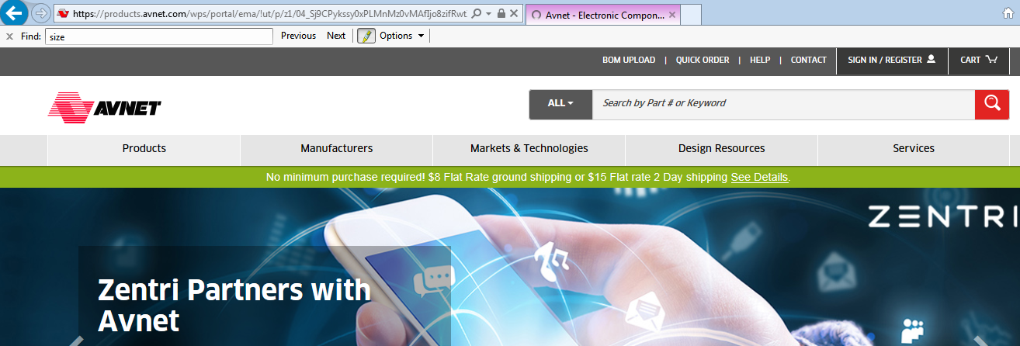

Asia Portal page

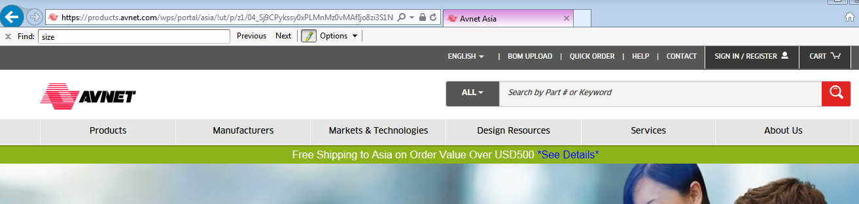

# **Top Navigation – Flyout Display**

**Products and Manufacturers Display in Portal page**

Products and Manufacturers are rendered from WCS. Products and manufacturers json response are exposed to Portal team with the help of below URL. This URL will be invoked by Portal through some daily job and response will be saved offline, for displaying in front end. Daily job ensures the availability of latest data.

**EMEA**

<https://products.avnet.com/shop/en/emea/AvnHeaderFlyout?storeId=10151&catalogId=10001>

EMA

<https://products.avnet.com/shop/en/ema/AvnHeaderFlyout?storeId=715839035&catalogId=10001>

ASIA

<https://products.avnet.com/shop/en/asia/AvnHeaderFlyout?storeId=715839038&catalogId=10001&langId=-1> (for English)

<https://products.avnet.com/shop/en/asia/AvnHeaderFlyout?storeId=715839038&catalogId=10001&langId=-7> (for Chinese)

Above URL invokes the jsp, “AvnStaticHeader.jsp”, where for products, below EMEA sample REST call is used.

http://corvette1:24000/search/resources/store/10151/categoryview/@top?pageSize=1000&catalogId=10001&depthAndLimit=11%2C11&pageNumber=1&responseFormat=json&langId=-1&contractId= 10006

Master REST call to fetch Manufacturers for EMEA would be like below. Result of below REST call is iterated and more information on individual manufacturers are obtained from further REST calls in the jsp.

http://corvette1:24000/search/resources/store/10151/sitecontent/brandSuggestions?searchType=100&profileName=Avn_findNavigationSuggestion_Brands&catalogId=10001&responseFormat=json&langId=-1&contractId=10006

**Other Flyout Content – Markets & Technologies, Design Resources, Services & About Us**

All these flyouts are rendered from WCM, with the help of the REST call provided by portal Team.

**PORTAL REST URLs**

EMEA Rest URL

<http://diexp.avnet.com/wps/portal/caas?current=true&urile=wcm:path:Web%20Content/Navigators/NavigatorContent&mime-type=application/json&tab_id=emea>

EMA REST URL

<http://diexp.avnet.com/wps/portal/caas?current=true&urile=wcm:path:Web%20Content/Navigators/NavigatorContent&mime-type=application/json&tab_id=ema>

ASIA REST URL

<http://diexp.avnet.com/wps/portal/caas?current=true&urile=wcm:path:Web%20Content/Navigators/NavigatorContent&mime-type=application/json&tab_id=asia> (for English)

<http://diexp.avnet.com/wps/portal/caas/!ut/p/z1/hVHNcoIwGHyV9uCR-UJAqUdkmLFWwCIWkgsTaNA4EFAY1D696HiAGdvmlN3sfj8boBABlawVW9aIUrK8w4ROYjQ45vvKdx08U9GbDl9AVjMg4cd5GW4hfCLvGRHQv6uRzm_8LlAhbAU_wUaWx6Kbbg0UaJWKbyDcYGOsJZqC-XSs6BM9VRKuYUXlKUYYZ9xIpzd1aDnx58b2u04NS-KbldWCAbE817WtwPMt05rbQFzPte9sYLvBkOuBOYLFf0t1GYr94UBNoIUouNJcKg4Rq6pcpPecR2hfl7KvS0vZ8HMD0YknL3cgmxF6_Ex5rHv3x2sXPX0yyCD89c8OqkJeFLJoHdPMdnm7zAL99QpkRazH/dz/d5/L2dBISEvZ0FBIS9nQSEh/?tab_id=asia&CONNECTORCACHE=NONE&CONTENTCACHE=NONE&CACHE=NONE>

(for Chinese)

**Emspots**

All sections from “Markets & Technologies” till “About Us”, in the flyout are configured through an emspot, “AvnStaticFlyout_EMA” in WCS Management Centre, which again is related to the emspot content of each Store, through Web activity.

Emspot content for each Store is

“AvnStaticFlyout_EMS_SilicaContent” for EMEA

“AvnStaticFlyout_EMS_EMAContent” for EMA and

“AvnStaticFlyout_EMS_AsiaContent” for Asia

**Job Scheduler to update above Emspot content**

A Job Scheduler is configured in WCS Administration Console, PortalContentFetchCmd, to update above emspot contents. Steps to configure Job Scheduler for EMEA is checked-in as “EMEA Portal Integration Configuration.docx” in svn path.

[http://cis1785vmsvn.avnet.com/svn/Digital_Exp_Repo/branches/DXP_16.3.0/SetupDocuments/EMEA Setup Docs/EMEA Portal Integration Configuration.docx](http://cis1785vmsvn.avnet.com/svn/Digital_Exp_Repo/branches/DXP_16.3.0/SetupDocuments/EMEA%20Setup%20Docs/EMEA%20Portal%20Integration%20Configuration.docx)

The job parameter for Job scheduler is the emspot content name, viewurl(path to the jsp which builds the emspot content html), storeId and catalogId like the one below. For Asia, langId is also needed since Asia supports both English and Chinese.

*Job Parameter Examples*

emsContent=AvnStaticFlyout_EMS_SilicaContent&viewUrl=http://diexp-preprod.avnet.com/webapp/wcs/stores/servlet/AvnStaticHeader&storeId=10151&catalogId=10001

emsContent=AvnStaticFlyout_EMS_AsiaContent&viewUrl=http://diexp-preprod.avnet.com/webapp/wcs/stores/servlet/AvnStaticHeader&storeId=715839038&catalogId=10001&langId=-7

emsContent=AvnStaticFlyout_EMS_EMAContent&viewUrl=http://diexp-preprod.avnet.com/webapp/wcs/stores/servlet/AvnStaticHeader&storeId=715839035&catalogId=10001

*Logic in PortalContentFetchCmd*

Command runs the viewurl passed in Job scheduler and obtains the html. Then that html response is updated in emspot content table with below query in the PortalContentFetchCmdImpl.

update COLLDESC set MARKETINGTEXT= ? ,LONGMKTGTEXT =? where collateral_id in (select collateral_id from collateral where name = ?) AND LANGUAGE_ID=?

Example viewUrl for EMEA

<http://diexp-preprod.avnet.com/webapp/wcs/stores/servlet/AvnStaticHeader&storeId=10151&catalogId=10001>

Above URL can be hit directly to validate the html structure of emspot and to see whether PortalREST URL is properly getting iterated to build the html.

# 

# **Search Functionality**

Search functionality is driven by WCS.

**Search from Portal Page (/wps/portal page)**

When Search button is clicked from Portal, below URL is invoked.

<https://products.avnet.com/shop/SearchDisplay?categoryId=&storeId=10151&catalogId=10001&langId=-1&sType=SimpleSearch&resultCatEntryType=2&searchSource=Q&searchType=100&selectedSpeedBoat=T&avnSearchType=all&searchTerm=capacitor>

Products Listing in Search Results Page

Search results are exactly same in WCS and Portal side for EMA and Asia. But for EMEA, search results from Portal should give only products within the particular speedboat. To indicate the portal site from which search is triggered, extra attribute, **selectedSpeedBoat** is passed.

*Different values of parameter selectedSpeedBoat*

S Silica (Only Silica Products will be listed)

T Abacus (Only Abacus Products will be listed)

E Ebv (Only Ebv Products will be listed)

JSP code logic is in “SearchSetup.jspf”. SOLR search expression with erpDivCode is built in AvnSolrRestErpExpressionProvider.java.

Manufacturers Listing in Search Results Page

On searching from Portal page, only static manufacturers configured against the speedboat should get listed. This is again controlled by the parameter “selectedSpeedBoat”. Manufacturers result of below 2 URLs helps to understand the result. First one will return static manufacturers content and second one will return only the manufacturers in WCS database

*Search from Portal*

<https://products.avnet.com/shop/SearchDisplay?categoryId=&storeId=10151&catalogId=10001&langId=-1&sType=SimpleSearch&resultCatEntryType=2&searchSource=Q&searchType=100&selectedSpeedBoat=T&avnSearchType=all&searchTerm=aavid>

*Search from WCS*

<https://products.avnet.com/shop/SearchDisplay?categoryId=&storeId=10151&catalogId=10001&langId=-1&sType=SimpleSearch&resultCatEntryType=2&showResultsPage=true&searchSource=Q&searchType=100&pageView=&beginIndex=0&pageSize=3&avnSearchType=all&searchTerm=aavid>

Static manufacturer pages are indexed with the SOLR configurations in droidConfig.xml, which reads WCMSiteMap xmls, where all the portal page urls for Static manufacturers are configured. These static manufacturer pages should have tika tags configured in the meta data.

Unstructured SOLR index for static content can be verified by below SOLR URLs

http://charlotte2:24000/solr/MC_10001_CatalogEntry_Unstructured_en_US/select?q=tika_page_type:Manufacturer

http://charlotte2:24000/solr/MC_10001_CatalogEntry_Unstructured_en_US/select?q=tika_page_type:Marketing

**Search from WCS Page**

On triggering search from WCS Pages, “selectedSpeedBoat” attribute will not be passed and hence all products across speedboats will be listed.

If “selectedSpeedBoat” is not passed, we will be listing all the products for the term searched, across speedboats.

# **Auto Suggest Functionality**

Auto Suggest is driven from WCS.

*AutoSuggest from Portal Page*

Below URL is invoked from Portal Page to obtain htmls for AutoSuggest.

<https://products.avnet.com/shop/SearchComponentAutoSuggestView?coreName=MC_10001_CatalogEntry_en_US&langId=-1&storeId=10151&catalogId=10001&term=diode&showHeader=true&avnSearchType=all&objectId=&requesttype=ajax&selectedSpeedBoat=T>

Here again it’s distinguished that call is from Portalpage with the extra parameter passed, “selectedSpeedBoat”. Landing jsp for above call is “AvnAutoSuggestSerialize.jsp”. This view returns the html, which is parsed and displayed in Portal end with “autosearch.js”, which is equivalent of the java script in WCS end, “Search.js”. “autosearch.js” in WCM end is owned by WCS.

Changes in Portal Page compared to WCS Page on Auto Suggest results

1. Order of listing of items is different in Portal Page compared to WCS Page, whenever selectedSpeedBoat parameter is passed.

Order in Portal Page

*Auto Suggestions for Items configured in Portal Site*

Static Manufacturers

Others

A Green Bar to separate portal content with WCS content

Products

Events

Softwares

Tools

Documents

Videos

Suggested Keywords

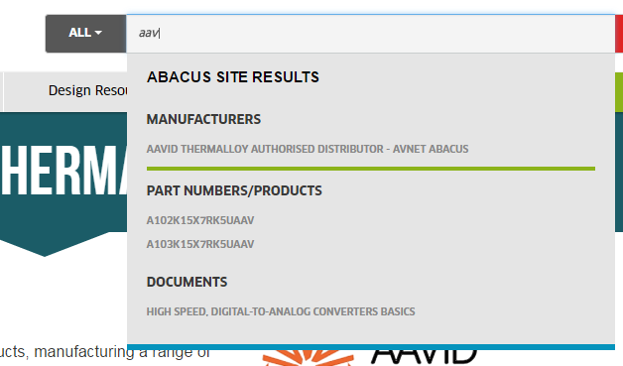o

Order of Listing in WCS Side

Products

Manufacturers

Categories

Articles

Softwares

Tools

Documents

Videos

Events

Others

Suggested Keywords

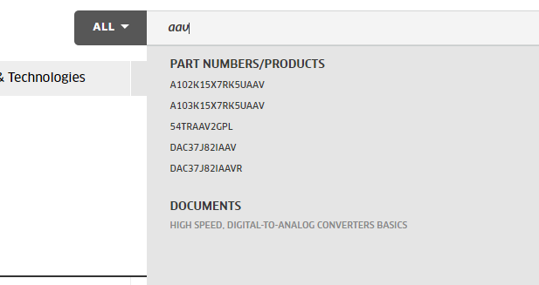

1. Auto Suggest in Portal Page lists only Static manufacturers, except for EMEA Portal Page, whereas in WCS Page, Auto Suggest list manufacturers in WCS table.

# **Portal links in WCS header**

Portal Integration Feature

In WCS end, we have created new feature “PortalIntegration”, so that when the feature is enabled, links in header, like for, “Help”, “Contact”, Logo link etc will be pointing to the corresponding Portal Site URLs. If Portal Integration feature is disabled, URLs will be pointing to WCS topCategories display URL itself (WCS Home Page).

Portal URLs configured in Storeconf

Portal URLs are configured in STORE CONF table for each Store, like below. Server domain will be appended with below links in STORE CONF table to create each Portal URLs

*Sample values for EMEA Store*

wc.avn.portalPath /wps/portal/emea/ (Link in logo)

wc.avn.portalPath.abacus /wps/portal/abacus (Abacus link in the header for EMEA)

wc.avn.portalPath.contact about-us/contact-us (Contact Us link)

wc.avn.portalPath.ebv /wps/portal/ebv (Ebv link in the header for EMEA)

wc.avn.portalPath.help services/online_help (Help link in the header)

wc.avn.portalPath.silica /wps/portal/silica (Silica link in the header for EMEA)

For EMA wc.avn.portalPath will be /wps/portal/ema/

For Asia wc.avn.portalPath will be /wps/portal/asia/

All these URLs are read in EnvironmentSetup.jspf and set into request scope.

# **WCS links in Portal Page header**

Below links in Portal Page redirects to WCS. Below are sample URLS for EMEA. For EMA & Asia, respective StoreIds should be passed.

BOM Upload:

<http://products.avnet.com/shop/AvnBomUploadView?catalogId=10001&langId=-1&storeId=10151>

Quick Order

[http://products.avnet.com/shop/AvnQuickOrderAddView?catalogId=10001&langId=-1&storeId=10151](http://products.avnet.com/shop/AvnBomUploadView?catalogId=10001&langId=-1&storeId=10151)

Sign in :

<https://products.avnet.com/shop/LogonForm?catalogId=10001&langId=-1&storeId=10151>

My Avnet:

<https://products.avnet.com/shop/AvnDashboardView?catalogId=10001&langId=-1&storeId=10151>

Quick Order:

<http://products.avnet.com/shop/AjaxQuickOrderAddView?catalogId=10001&langId=-1&storeId=10151>

Cart :

<https://products.avnet.com/shop/AjaxOrderItemDisplayView?catalogId=10001&langId=-1&storeId=10151>

LogOff:

<https://products.avnet.com/shop/Logoff?catalogId=10001&myAcctMain=1&langId=-1&storeId=10151&URL=%2Fwps%2Fportal%2Fabacus%2F&deleteCartCookie=true>